**CURRICULAM VITAE**

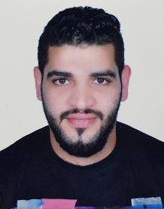

**PERSONAL DETAILS:**

NAME : Mohamed Hussain Ibrahim

Mohamed Ahmed

NATIONALITY: Bahraini

DATE OF BIRTH: 31/12/1994

MARITAL STATUS: Married

ADDRESS: Karbabad – Bahrain .

C.P.R.: 941211150

TELPHON NO.: 36663171

**EDUCATIONAL BACKGROUND:**

* School .

**WORK EXPERIENCE:**

* **Driver – 3 years.**
* **Security – 1 year.**
* **Cashier – 1 year.**

**LANGUAGES:**

Good spoken and written Arabic and English.

**SKILLS :**

*Easy to communicate with others and good ability to build social relationships.

* Ability to adapt to any work conditions and work under pressure.

* Ability to work individually or within a team.

*Ability of handling multitasks.

* Excellent driver and I know Bahrain roads very well.

*Ability of personal development.

*Ability to use Microsoft office programs.